COURSE Diploma of Information Technology (VDIT)

UNIT OF STUDY VIT1104 – Computer Networks

ASSESSMENT TITLE Lab Task 2

ASSESSMENT TYPE Lab Work

Student name: ___Aleksandar Ivanov__ Student ID: ____s8090291________
Instructor name: ______Mohana______ Date: ___5.17.2023___Group:__________

Instructions

- Weighting This assessment is worth 10% of your final result for this unit of study.
- You must put your VU student ID on all items submitted for assessment.
- You have 60 minutes to complete this assessment.
- This assessment is restricted OPEN BOOK. Only your paper based study notes or engineering hand written journals are permitted. No electronic resources or storage devices are allowed.
- Name your Packet Tracer Solution file Lab Task 2 s1234567.pka where the digits represent your student ID.
- Download the Assessment Packet Tracer Activity File (Lab Task 2 – Assessment.pka) under Assessment Information - Lab Task 2 – Assessment.
- Rename the Packet Tracer Activity file Lab Task 2 s1234567.pka where the digits represent your student ID. Save this file.
- Complete all steps in Part 1 – 2 in this assessment. Answer the reflection questions.
- When you are ready to submit the completed solution please make sure you do the following:
- Save the file.
- Upload the Packet Tracer file Activity file solution to Assessment - Lab Task 2 drop box on your VU Collaborate space.
- Upload this Assessment sheet with your answers to the reflection questions to the Assessment - Lab Task 2 drop box on your VU Collaborate space.

Resources required

- PC with Packet Tracer Software (student version) installed
- Select Cisco Models1941 routers and 2960 Catalyst switches
- Access to the VU Collaborate Learning Management System.
- Assessment Packet Tracer File

Topology
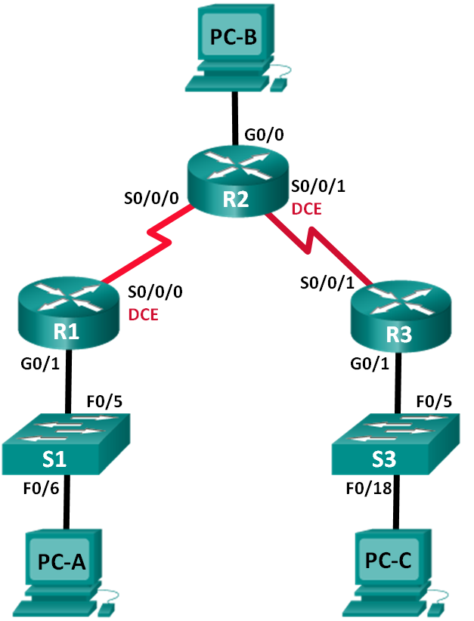

Addressing Scheme
Device | Interface | IP Address | Subnet Mask | Default Gateway | Interface Description
R1 | G0/1 | 172.18.10.1 | 255.255.255.0 | N/A | GATEWAY TO R1 LAN
 | S0/0/0 (DCE) | 172.18.12.1 | 255.255.255.252 | N/A | WAN LINK TO R2
R2 | G0/0 | 209.165.201.1 | 255.255.255.0 | N/A | GATEWAY TO R2 LAN
 | S0/0/0 | 172.18.12.2 | 255.255.255.252 | N/A | WAN LINK TO R1
 | S0/0/1 (DCE) | 172.18.23.1 | 255.255.255.252 | N/A | WAN LINK TO R3
R3 | G0/1 | 172.18.30.1 | 255.255.255.0 | N/A | GATEWAY TO R3 LAN
 | S0/0/1 | 172.18.23.2 | 255.255.255.252 | N/A | WAN LINK TO R2
S1 | VLAN 1 | 172.18.10.11 | 255.255.255.0 | 172.18.10.1
S3 | VLAN 1 | 172.18.30.33 | 255.255.255.0 | 172.18.30.1
PC-A | NIC | 172.18.10.10 | 255.255.255.0 | 172.18.10.1
PC-B | NIC | 209.165.201.2 | 255.255.255.0 | 209.165.201.1
PC-C | NIC | 172.18.30.30 | 255.255.255.0 | 172.18.30.1

Objectives
Part 1: Build the Network and Configure Basic Device Settings
Part 2: Configure and Verify RIPv2 Routing

Background / Scenario
RIP version 2 (RIPv2) is used for routing of IPv4 addresses in small networks. RIPv2 is a classless, distance-vector routing protocol, as defined by RFC 1723. Because RIPv2 is a classless routing protocol, subnet masks are included in the routing updates.
In this lab, you will configure the network topology with RIPv2 routing, disable automatic summarization, propagate a default route, and use CLI commands to display and verify RIP routing information.

Required Resources
- 3 Routers (Cisco 1941)
- 2 Switches (Cisco 2960)
- 3 PCs (Terminal Emulation App available)
- Console cables to configure the Cisco IOS devices via the console ports
- Ethernet and Serial cables as shown in the topology

Reflection Questions

There are 6 reflection questions on this assessment. There are NO MARKS given for answering reflection questions. Your answers to these questions are evidence to verify that your submission is your work. You must complete all reflection questions and then submit this assessment document to the specified drop box.

- Build the Network and Configure Basic Device Settings
In Part 1, you will set up the network topology and configure basic settings.
  - Cable the network as shown in the topology.
  - Initialize and reload the router and switch.
  - Configure basic settings for each router.
    - Disable DNS lookup.
    - Configure device names as shown in the topology.
    - Configure password encryption.
    - Assign class as the privileged EXEC password.
    - Assign cisco as the console and vty passwords.
    - Configure a banner with the message of the day: “Unauthorised Access is Prohibited”
    - Configure logging synchronous for the console line.
    - Configure the IP addresses listed in the Addressing Table for all interfaces.
    - Configure a description for each interface as per the Addressing Scheme Table.
    - Configure the clock rate, if applicable, to the DCE serial interface.
    - Copy the running-configuration to the startup-configuration.
  - Configure IP addressing on Switches.
    - Configure SVI Management IP address and default gateway on each switch.
  - Configure PC IP Addressing.
    - Refer to the Addressing Table for IP address information of the PCs.
- Configure and Verify RIPv2 Routing
  - Configure RIPv2 Routing on all Routers.
  - Advertise the appropriate networks (Do not send routing updates to LANs)
  - Disable Auto-Summarisation on all RIP routing.
  - Configure and redistribute a default route for Internet access.
  - Verify the routing configuration.
  - Verify connectivity.

Reflection Questions

- Enter the command used to view the routing table of each router?
Show IP route

- How many RIP route entries are listed in router R2’s routing table?
2 route entries, R 172.18.10.0/24 [120/1] via 172.18.12.1, 00:00:18, Serial0/0/0
R 172.18.30.0/24 [120/1] via 172.18.23.2, 00:00:19, Serial0/0/1

- List all the learned routes in router R1’s table:
172.18.0.0/16 is variably subnetted, 6 subnets, 3 masks
C 172.18.10.0/24 is directly connected, GigabitEthernet0/1
L 172.18.10.1/32 is directly connected, GigabitEthernet0/1
C 172.18.12.0/30 is directly connected, Serial0/0/0
L 172.18.12.1/32 is directly connected, Serial0/0/0
R 172.18.23.0/30 [120/1] via 172.18.12.2, 00:00:01, Serial0/0/0
R 172.18.30.0/24 [120/2] via 172.18.12.2, 00:00:01, Serial0/0/0

- Why do we need to disable auto summarisation in our RIP configuration?
RIP – protocol to not summarize its routes to their boundary networks automatically.

- How did routers R1 and R3 learn the pathway to the internet?
When the routers has been configured (RIP) with the right pathway (ip addresses)

- How did routers R1 and R3 learn about each other’s private LAN networks?
They learned because of the Dynamic Configuration routing (RIP)

NOTE: I added description at R2 to interface s0/0/1, but it wont show up.

RUBRICS
- You are free to choose own host addresses (within the host range of each network) for your device’s interfaces.

RUBRICS | Your Marks | Marks possible
Disable DNS lookup (1 mark for each network device) |  | 3
Device host names (1 mark for each network device) |  | 3
Message of the day (1 mark for each network device) |  | 3
Encrypted privileged exec password (1 mark for each network device) |  | 3
Console access password (1 mark for each network device) |  | 3
Telnet access Password (1 mark for each network device) |  | 3
Encrypt all clear passwords (1 mark for each network device) |  | 3
Set clock on the routers (1 mark for each network device) |  | 3
Save the running configuration files on all routers devices (1 mark for each) |  | 3
Assign appropriate IP addresses/Subnet mask/Default Gateways on interfaces of 3 PCs |  | 9
Assign appropriate IP addresses/Subnet mask/Descriptions on Router’s Lan interfaces (R1 G0/1, R2 G0/0, and R3 G0/1). Activate interfaces. |  | 14
Assign appropriate IP addresses/Subnet mask/Descriptions on Router’s Serial interfaces (R1 s0/0/0, R2 s0/0/0, s0/0/1, R3 s0/0/1). Activate interfaces. |  | 23
Assign appropriate IP address/Subnet mask and Default Gateway on each LAN Switch. |  | 6
Configure RIPv2 routing on each router |  | 3
Advertise the required networks (do not send routing updates to any LANs) |  | 6
Disable Auto-Summarisation |  | 3
Propagate the default route into the RIP domain |  | 2
Use the ping or trace utility to test connectivity for the following:
PC-A can communicate with internet (R2’s PCB) |  | 1
PC-C can communicate with internet (R2’s PCB) |  | 1
PC-A can communicate with PC-C |  | 1
PC-A can communicate with Switch S1 |  | 1
Switch S1 can communicate with internet (R2’s PCB) |  | 1
PC-C can communicate with Switch S3 |  | 1
Switch S3 can communicate with internet (R2’s PCB) |  | 1
Total Marks |  | /100
Total Adjusted |  | /10

Refer to the Activity Results with breakdown of items given by the Packet Tracer Assessment Activity File at the end of the assessment session. Your result for this assessment is the total points correctly configured assessment items (out of 93) and successful connectivty tests (out of 7).

